

**Hotel Cancel Culture: Who Will Cancel?**

**INTRODUCTION**

**Who?**

* 🏢 **Revenue Management (RM) teams** for hotel groups (corporate, franchise)
* 🏨 On-site GMs, Sales, and Ops teams

**Why?**

* 💰 **Revenue Management:**
  + Revenue optimization: Right price, right time, right customer
    - Dynamic pricing
    - Distribution channels
    - Pricing per room type
* 🤝 **Sales:**
  + Group sales (pickup/wash)
  + BT (performance/company for both GPP and LNR rates)
* 🛌 **Rooms Ops:**
  + Forecasting occupancy, arrivals, departures, stay-overs, same-day booking demand, and probability of guest relocation in the case of oversell.
  + Determining staff schedules and periods of high demand
* 🍰 ☕ **Food and Beverage:**
  + Ordering food/supplies overall
  + Scheduling staff
  + Determining busy times (breakfast, lunch, dinner)
    - Staffing, specific food/supplies

**What?**

* 🧾 Dataset comprised of...
  + 32 different features
    - Detailed explanation of features (and sub-categories, when appropriate) available in Readme
  + Nearly 120,000 reservation records
  + Source cited in Readme

❌ **How?**

* Which models/methods?
* Data prep and feature engineerin

Business Problem

**Goal:** determine whether or not a reservation would cancel given different details of a guest and their reservation.

his dataset contain information of hotel booking, We will perform exploratory data analysis to get insight from the data.

We will try to analyze the important factors that governs the bookings in the following steps:

1. We will try to find out the

**Total number of Hotel Bookings that were get Cancelled.**

2. Then we will find the **Booking Ratio between Resort Hotel and City Hotel.**

3. Now We will find **Hotel Booking Pecentage for Each Year.**

4. After all of these We'll try to get **Most busiest month for the Hotel.**

5. Find out the **Country From which we get Most number of guests.**

6. We will try to get for **How Long People Stay in the hotel.**

7. At last will try to get the **Most booked accommodation type (Single, Couple, Family/Friends).**

* Conceptual Background of the Domain Problem
* Data Preprocessing Done
* Visualizations

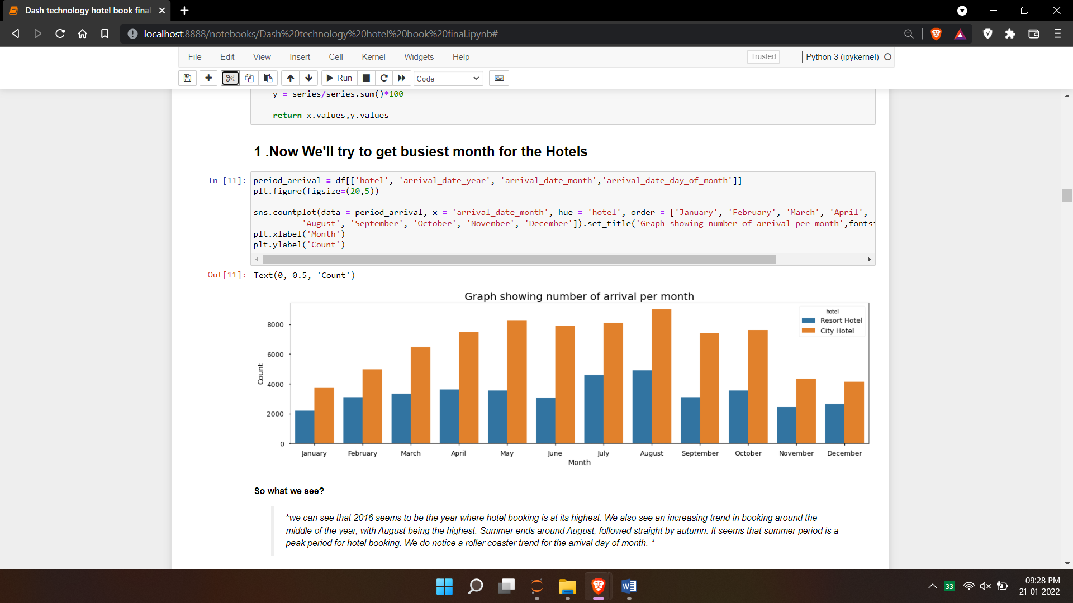

**OPERATION PERFORM ON DATA**

1. **Collected data for last three years i.e. 2015, 2016 and 2017**
2. **IMPORT DATASET FROM KAGGLE**
3. **IMPORT LIBRARIES FOR DATA PREPARATION AND VISUALIZATION**
4. **REMOVE NULL VALUES**
5. **DROP UNNECESSARY COLUMNS**
6. **PERFORM EDA AND FIND INFORMATION**
7. **FIND CORRELATION AND DESCRIBE DATA**
8. **VISUALIZATION**
9. **FIND PROBLEMS AND SOLUTIONS WITH THE HELP OF GRAPH**
10. **FIND OUTLIRE WITH THE HELP OF BOX PLOT**
11. **CONVERT CATEGORICAL TO NUMERICAL WITH LABEL ENCODER**
12. **SPLIT DATASET**
13. **APPLY MACHINE LEARNING ALGORITHEMS**
14. **EVALUATE THE MODEL**
15. **FIND WHERE NEED IMPROVEMENT**
16. **CHECK ACCURACY**

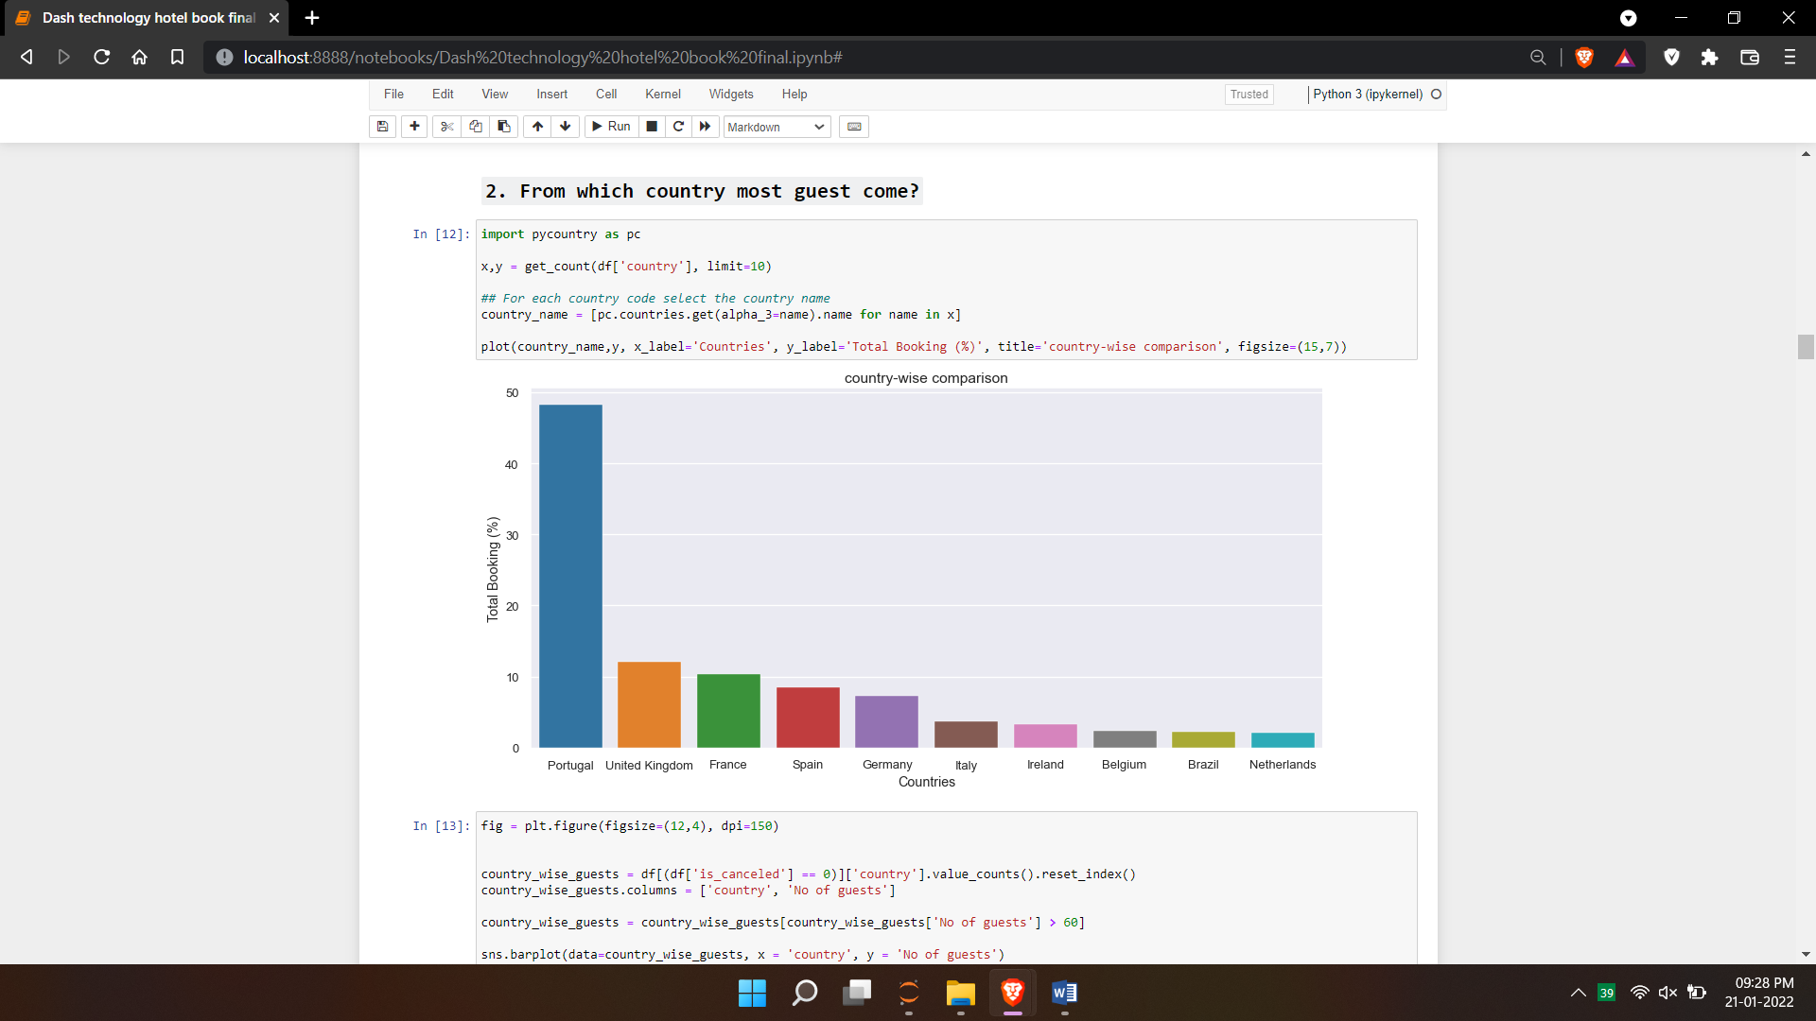 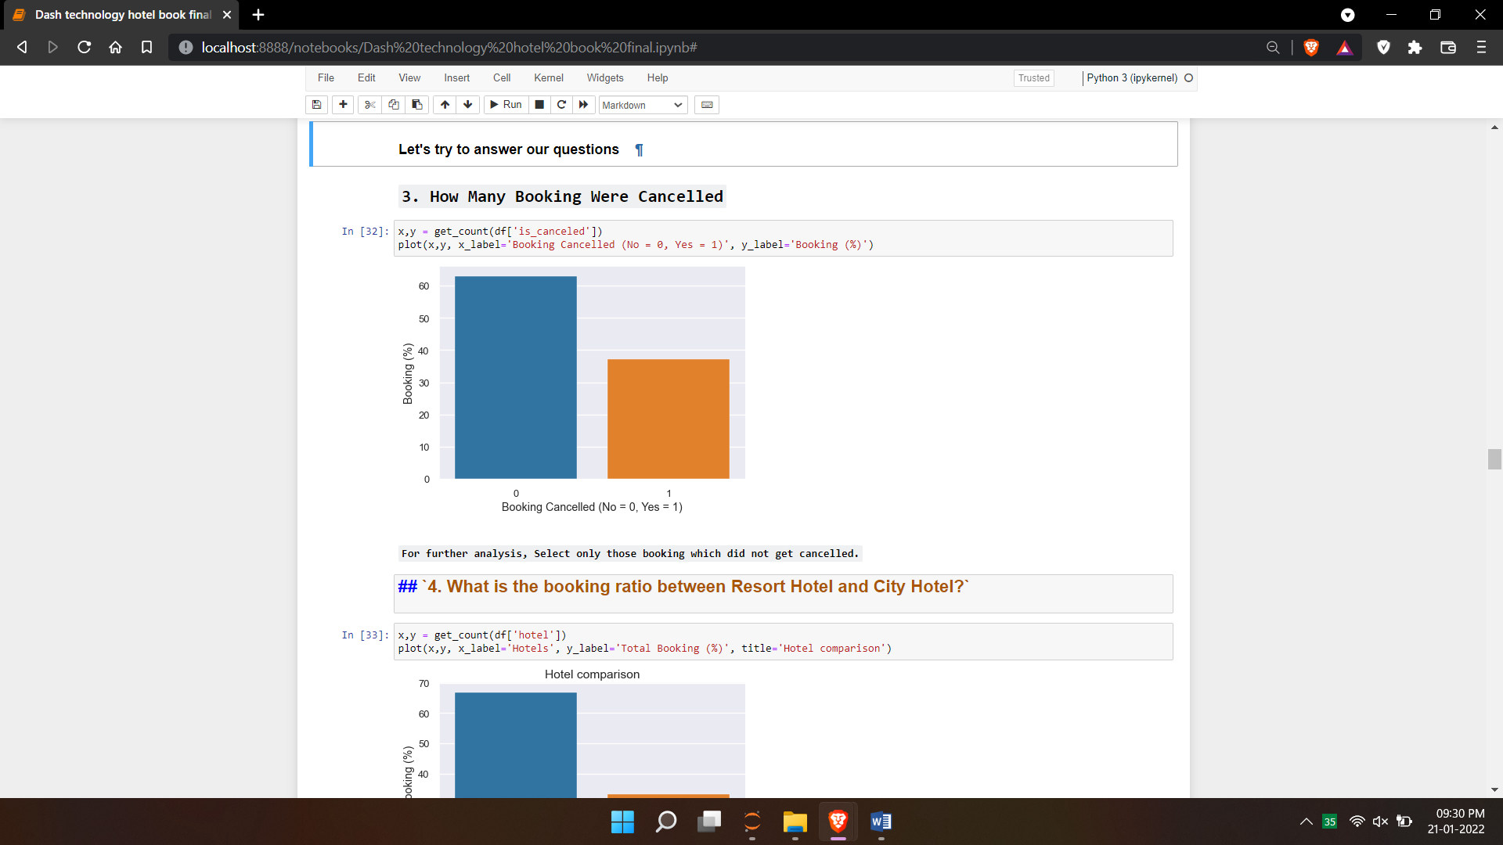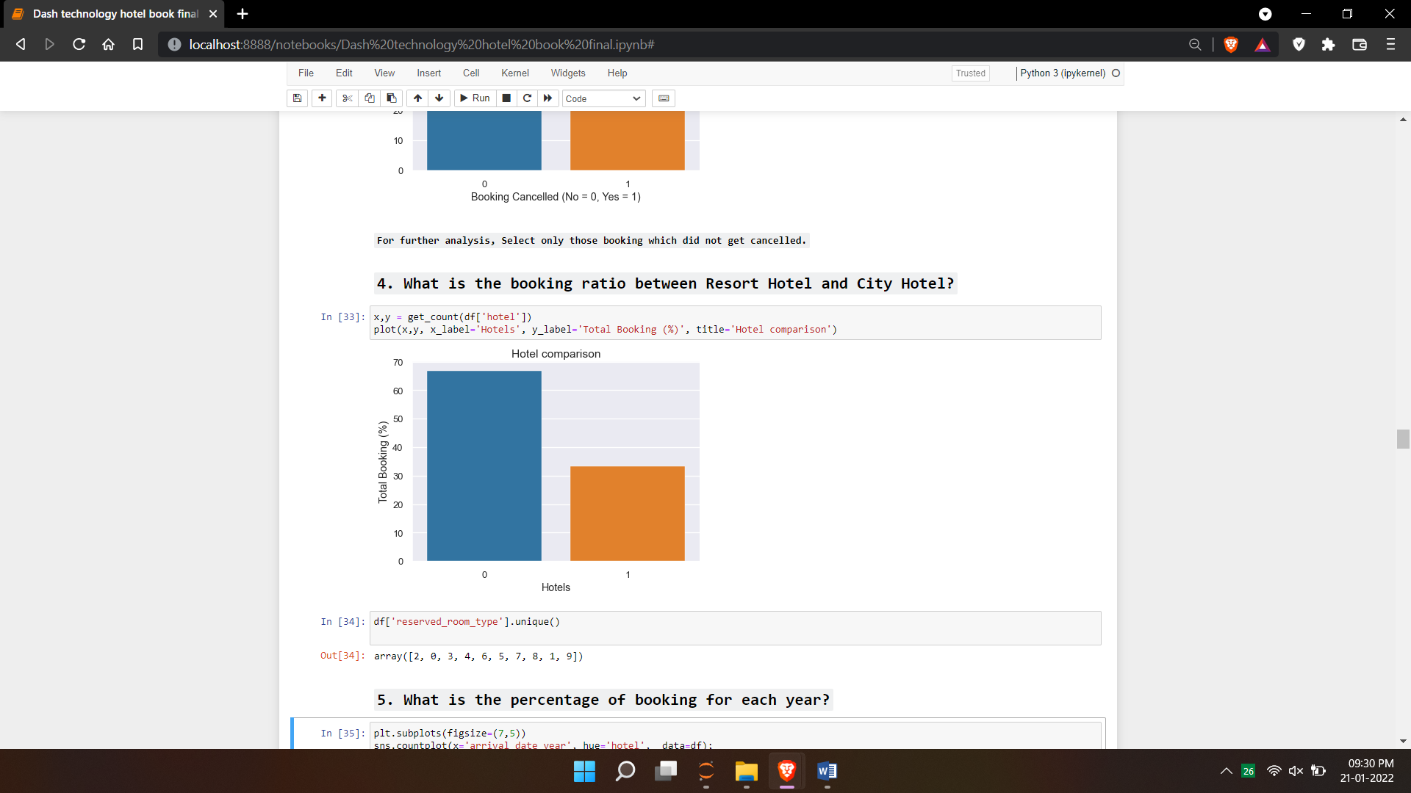

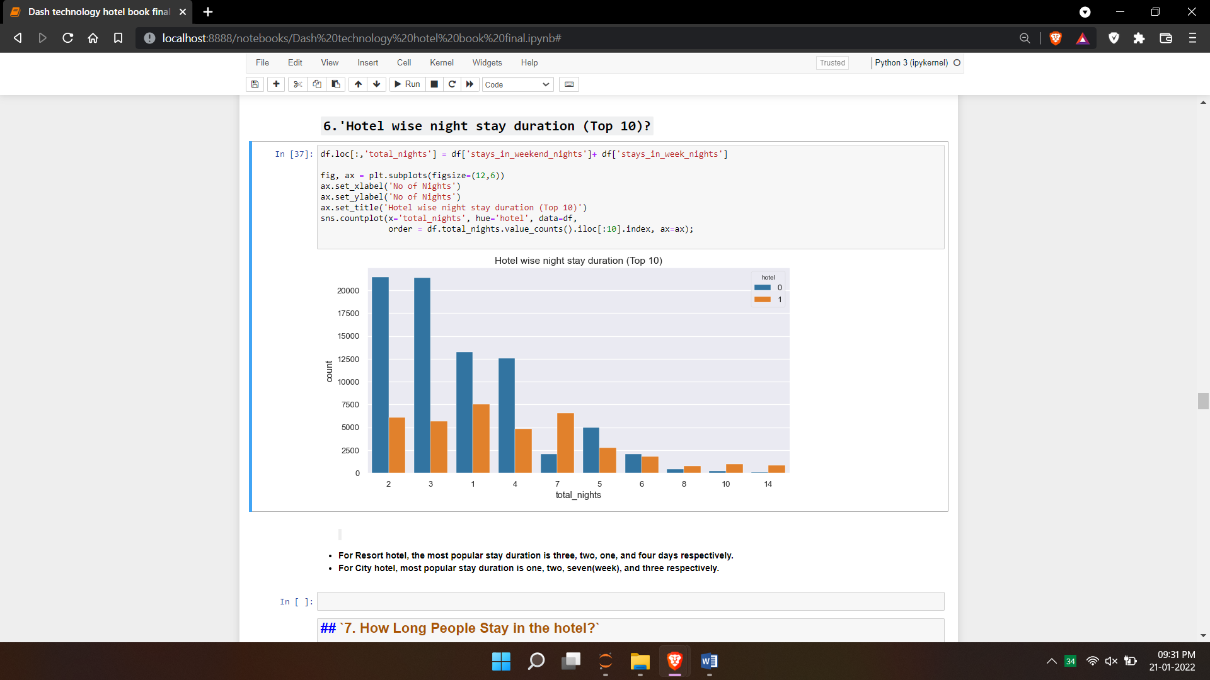

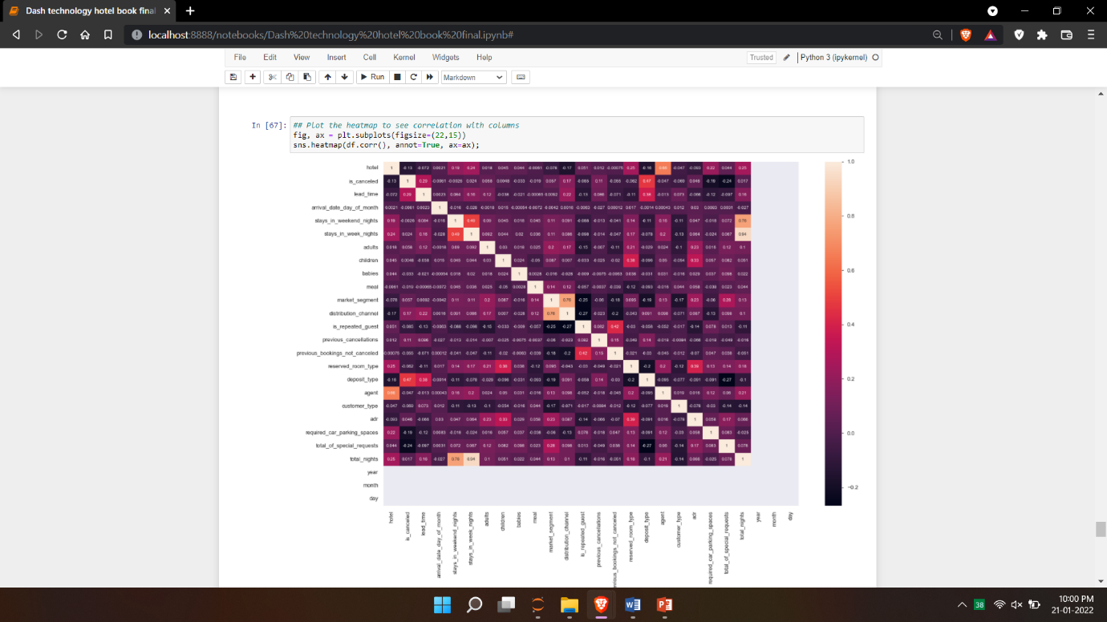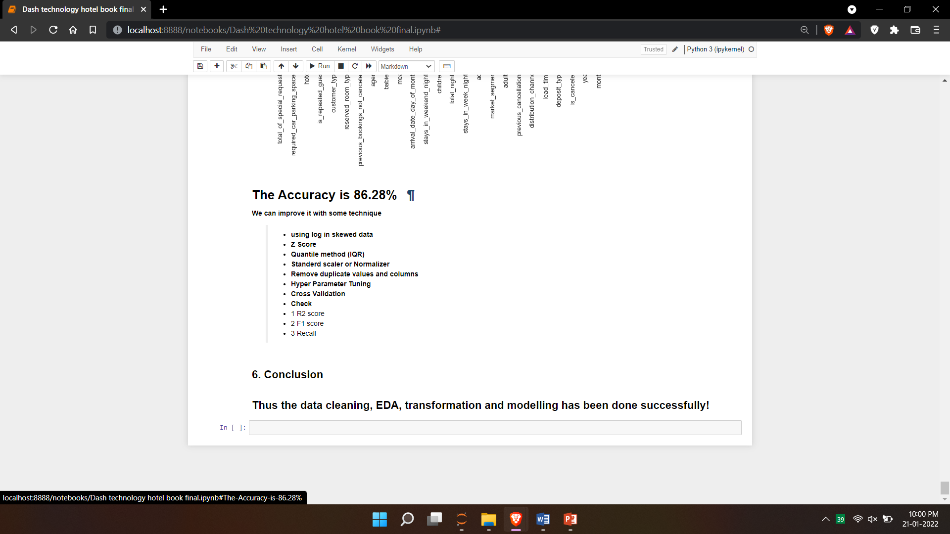

**Model/s Development and Evaluation**

* Identification of possible problem-solving approaches (methods)

**Regression and co relation.**

In statistical modeling, regression analysis is a set of statistical processes for estimating the relationships between a dependent variable and one or more independent variables

* Testing of Identified Approaches (Algorithms)

**Decision tree regression**

**Random forest regression**

**Support vector regression**

Natural log, and min-max scaling

And finally hyper parameter tuning

**CONCLUSION**

* Key Findings and Conclusions of the Study

Thus the data cleaning, EDA, transformation and modelling has been done successfully!